Assignment 06

Part 01

Part 02

Part 03

Part 04

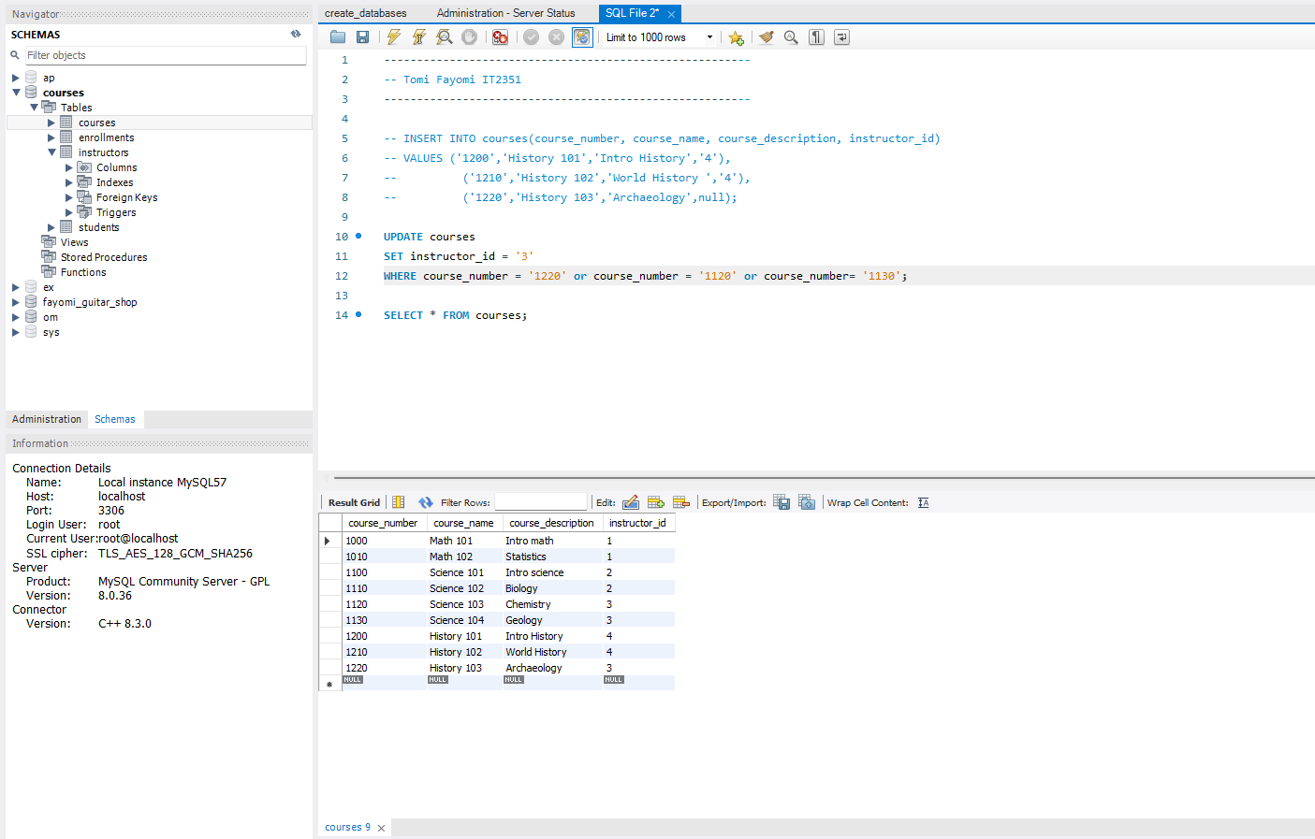

Part 05

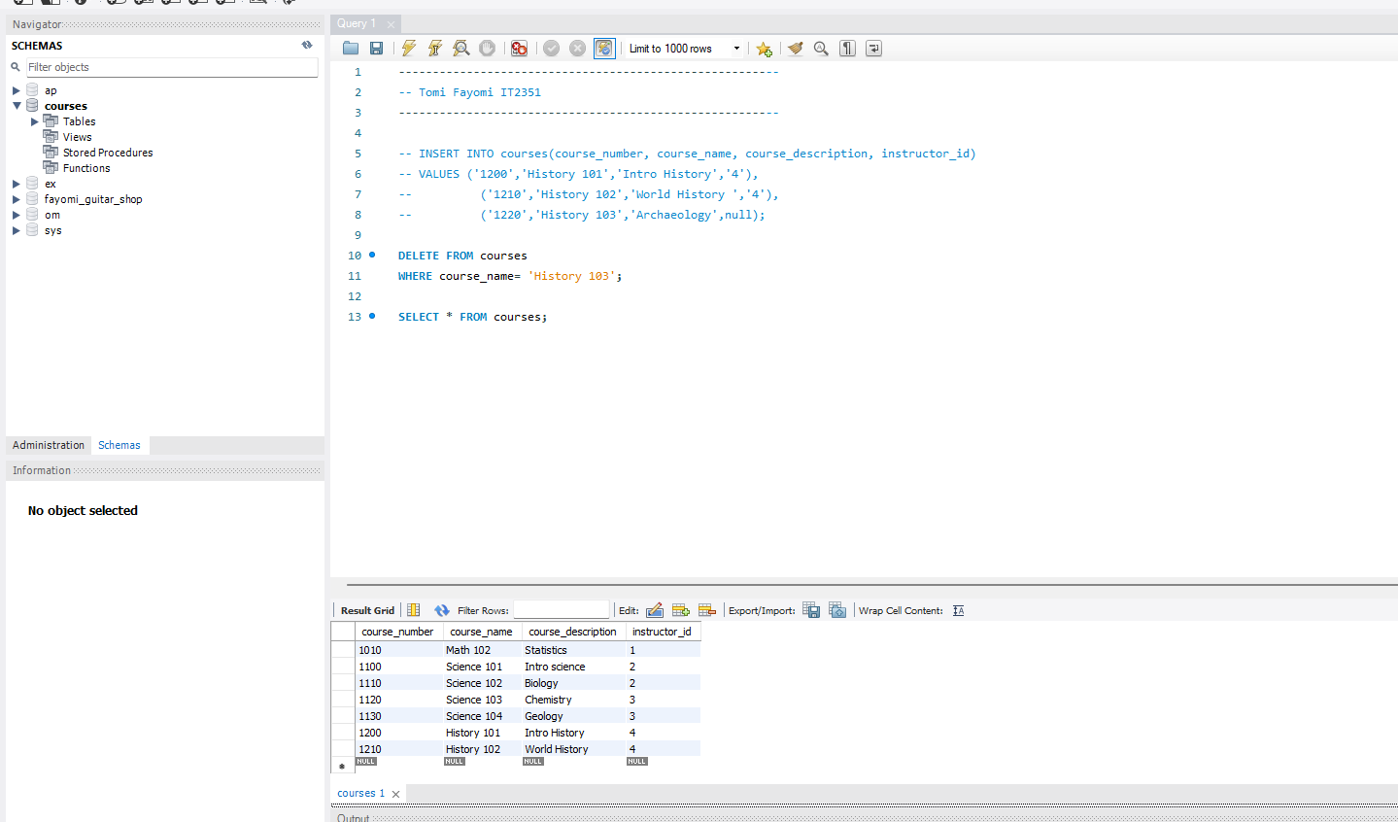

Part 06

